
INTERNATIONAL OFFICE
INTERNSHIP STUDENT LOGBOOK

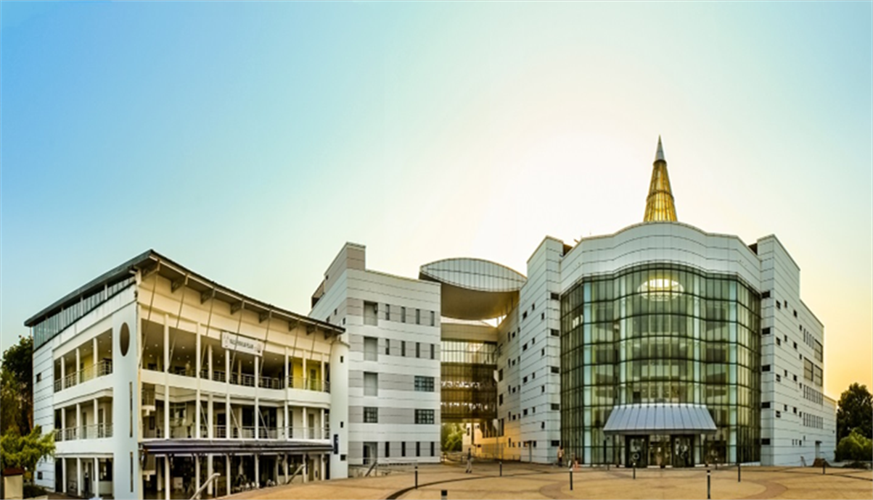


INDUSTRIAL TRAINING
LOG BOOK

Name | :  Putrajaya Campus, Jalan ikram-uniten,43000 kajang, Selangor, Malaysia | Zakaria MAKHROUB
Programme | : | Mobility international program
Home University | : | EMINES – UM6P
Attachment Unit | : | IICE
Supervisor | : | Dr Khairi AZIZ

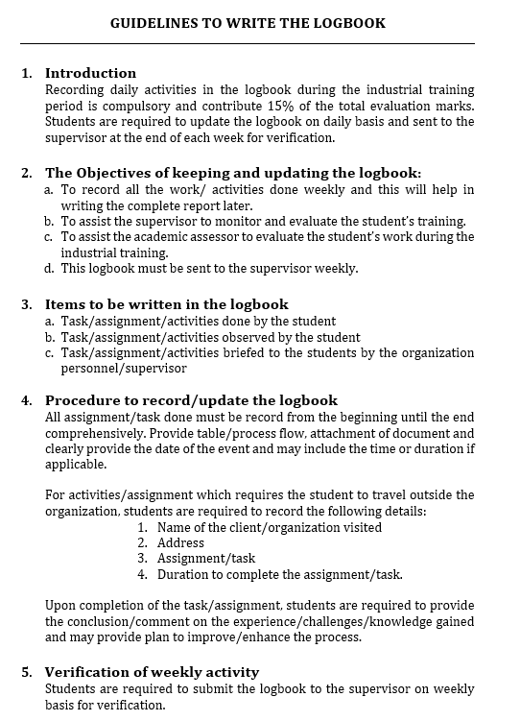

WEEKLY REPORTS

WEEK 1
DATE | TASK | SUPERVISOR’S REMARKS
22/6/26  -  24/6/26 | - Reviewed the GRIDPREDICT proposal and the Agentic AI Grant Pitching Deck to gain an understanding of the Agentic AI framework and predictive maintenance objectives.  - Read more about the project and attended a meeting with my supervisor.
25/6/26  26/6/26 | - Started searching for a suitable dataset for the project, identified a promising candidate, and am currently awaiting my supervisor's approval.
SUPERVISOR’S SIGNATURE

Sketching page
WEEK 2
DATE | TASK | SUPERVISOR’S REMARKS
29/06/2026 -  01/07/26 | - Tried to understand the role of the agents, how they work, and designed an initial architecture.  - Studied how the data will enter the system and how the agents will communicate with each other.
02/07/2026 | - Sent the proposed architecture to my supervisor and am waiting for approval.
03/07/2026 | - Started preparing the dataset for the project.
SUPERVISOR’S SIGNATURE

Sketching page
WEEK 3
DATE | TASK | SUPERVISOR’S REMARKS
06/07/2026 | Reviewed the selected dataset and organized the project data for preprocessing. | Data preparation continued.
07/07/2026 | Cleaned the turbine data and checked the structure, missing values, and date fields. | Dataset cleaning completed.
08/07/2026 | Met with my supervisor to discuss the progress of the project and the preparation of the report. Reviewed the work completed and received feedback for the next stage. | Progress discussed with supervisor.
09/07/2026 | Applied the feedback from the meeting and continued the data preprocessing and feature preparation. | Feedback incorporated.
10/07/2026 | Documented the preprocessing workflow and organized the results for inclusion in the report. | Report documentation updated.
SUPERVISOR’S SIGNATURE

Sketching page
WEEK 4
DATE | TASK | SUPERVISOR’S REMARKS
13/07/2026 | Implemented the feature engineering steps required for the predictive maintenance model. | Feature engineering continued.
14/07/2026 | Created the target variable and prepared the data for training and evaluation. | Training data prepared.
15/07/2026 | Generated time windows from the turbine data and checked the resulting samples. | Window generation completed.
16/07/2026 | Trained the initial XGBoost prediction model and reviewed its performance. | Initial model evaluated.
17/07/2026 | recorded the evaluation results for the report. | Model results documented.
SUPERVISOR’S SIGNATURE

Sketching page
WEEK 5
DATE | TASK | SUPERVISOR’S REMARKS
20/07/2026 | Integrated the trained model with the prediction pipeline and tested predictions on the processed turbine data. | Prediction pipeline tested.
21/07/2026 | Implemented the monitoring and decision logic for identifying turbine maintenance risks. | Risk analysis logic implemented.
22/07/2026 | Presented the project progress and completed report to my supervisor. Following the meeting, I was advised to proceed with developing the website based on the project requirements. | Report completed. Proceed with website development.
23/07/2026 | Reviewed the website requirements and planned the dashboard layout for turbine predictions and maintenance priorities. | Website development planned.
24/07/2026 | Started developing the website interface and connected it to the project processing pipeline. | Website implementation started.
SUPERVISOR’S SIGNATURE

Sketching page
WEEK 6
DATE | TASK | SUPERVISOR’S REMARKS
27/07/2026 | Developed the website page for selecting a date and viewing turbine risk information. | Date selection interface developed.
28/07/2026 | Added the turbine prediction results and maintenance priority information to the dashboard. | Prediction results displayed.
29/07/2026 | Implemented the report generation and download functionality for the selected date. | Report download implemented.
30/07/2026 | Connected the website components to the agents and tested the complete prediction workflow. | Agent workflow integrated.
31/07/2026 | Tested the website with the available turbine datasets and corrected data handling issues. | Initial website testing completed.
SUPERVISOR’S SIGNATURE

Sketching page
WEEK 7
DATE | TASK | SUPERVISOR’S REMARKS
03/08/2026 | Refined the website dashboard and improved the presentation of risk levels and maintenance rankings. | Dashboard presentation improved.
04/08/2026 | Added validation for date selection and handled cases where data is unavailable. | Input validation added.
05/08/2026 | Improved the generated report layout and verified the displayed summary metrics. | Generated report improved.
06/08/2026 | Tested the application with different turbine selections and prediction dates. | Functional testing continued.
07/08/2026 | Reviewed the website workflow and fixed issues identified during testing. | Testing issues resolved.
SUPERVISOR’S SIGNATURE

Sketching page
WEEK 8
DATE | TASK | SUPERVISOR’S REMARKS
10/08/2026 | Performed further integration testing of the data loader, model, agents, and website. | Integration testing completed.
11/08/2026 | Improved the website styling and made the dashboard clearer and easier to use. | User interface refined.
12/08/2026 | Checked the model outputs and maintenance rankings against the processed datasets. | Prediction outputs verified.
13/08/2026 | Ran the project tests and corrected remaining issues in the application workflow. | Remaining issues corrected.
14/08/2026 | Prepared the website for final review and organized the project outputs and documentation. | Final review preparation completed.
SUPERVISOR’S SIGNATURE

Sketching page

WEEK 9
DATE | TASK | SUPERVISOR’S REMARKS
17/08/2026 | Performed final end-to-end testing of the predictive maintenance website. | End-to-end testing completed.
18/08/2026 | Fixed final interface and workflow issues identified during the review. | Final corrections completed.
19/08/2026 | Verified the report generation, turbine rankings, risk classifications, and website outputs. | Outputs verified.
20/08/2026 | Completed the final documentation and prepared the website for delivery. | Website delivery preparation completed.
21/08/2026 | Finished the website for the wind farm predictive maintenance project and completed the final review of the implementation. | Website completed and project work finalized.
SUPERVISOR’S SIGNATURE

Sketching page
WEEK 10
DATE | TASK | SUPERVISOR’S REMARKS
SUPERVISOR’S SIGNATURE

Sketching page
WEEK 11
DATE | TASK | SUPERVISOR’S REMARKS
SUPERVISOR’S SIGNATURE

Sketching page
WEEK 12
DATE | TASK | SUPERVISOR’S REMARKS
SUPERVISOR’S SIGNATURE

Sketching page

Final Grading Form
(To be filled by the Supervisor)
ITEMS | MARKS | REMARKS
Host Supervisor Evaluation | / 25
Assessment of the Prototype / Research prepared by the Student | / 25
Assessment of the Report prepared by the Student | / 25
Logbook Evaluation | / 25

TOTAL MARKS = / 100%
GRADING = PASS / FAIL

Verified by Host University Representative,

__________________________+
( )

Verified by Home University Representative,

__________________________+
( )

